### **Openscape Business**

### **OPENSTAGE 15 TELEPHONE**

Your Openstage telephone has a display to assist you. If you like the option that is displayed, press the    key. If you want a different choice, use the ⯅ ⯆ scroll keys to move to the next option.

Preprogrammed keys on your Openstage 15 telephone:-

**PROGRAM**  Service menu.

**MAILBOX**  Calls the voicemail to access your mailbox.

**LOUD SPEAKER ** Handsfree operation.

**VOLUME**  and  Changes the volume and handset settings.

The 8 keys on the right side of the telephone are programmed as:-

**(2) GENERAL CALL**  Incoming call answer and indication buttons.

**SPARE KEY**   Keys not programmed.

**REDIAL KEY**  Redials last external number dialed.

**PARK A CALL**  Places calls on hold in a Park position.

10 locations from 0 – 9

**HOLD**  Places answered call on hold.

**RELEASE** Hangs the current call up / Releases the call.

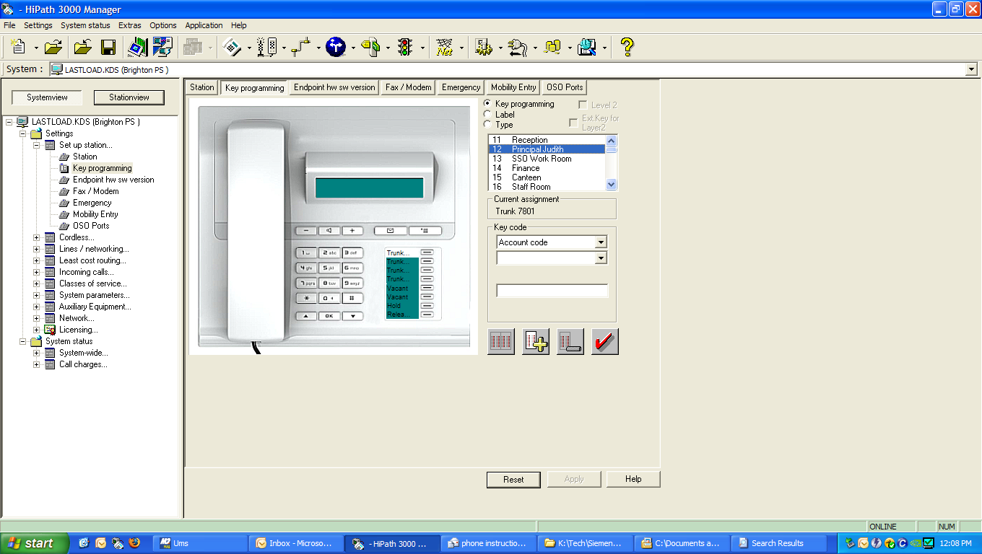

|  |  |
| --- | --- |
| **FUNCTION** | DESCRIPTION |
| **Phone Settings** | **To change the speaker volume of the handpiece.**   * Whilst in conversation, press + or – key near handpiece.   **To change the ringer volume.**   * With the handpiece in cradle press + button   Screen: Telephone Settings  Ringer volume?  .   * Press:  Press + or – key until desired volume is reached.  * Press: * to save.*   **To set the ringer tone.**   * With the handpiece in cradle press + button.   Screen: Telephone Settings  Ringer volume?   * Scroll down ⯆so that Ringer tone? is on the screen. * Press: * Press + or – key until desired tone is reached. * Press: * to save.* |

|  |  |
| --- | --- |
| **FUNCTION** | **DESCRIPTION** |
| **Internal Call** | Lift handset and dial the extension number you require, or use DSS (Direct Station Selection) key. |
| **External Call** | Lift handset **dial 0** for outside line, then dial the number you require. |
| **Answering Calls** | If the phone is ringing, lift the receiver. |
| **To Answer more than one call.** | You will have to decide whether you would like to:-Transfer call you are attending to – refer below.Place call on hold – refer below. |
| **(a) Transfer Call** | * Make sure “Enquiry?” is on the screen. * Press  key. * Key in extension number, or use DSS key. * Press **Release** key.  If the extension you are transferring to is busy or not answering the call, you can return to the call.  * Make sure “Return to held call?” is on the screen.  Press |
| **(b) Hold** | **To put 1st caller on hold.**   * Make sure “Enquiry?” is on the screen. * Press **Hold** key, then press **Release** key.   (Your 1st caller is on hold and a **line key** will flash slowly).  You are now free to accept second call.  **To get your 1st caller back.**   * Press slow flashing **Line** key. |
| **Handsfree Operation** | * If speaking to caller using handpiece and you wish to use handsfree, press and hold **Loudspeaker** key until you place handpiece in cradle. |
| **FUNCTION** | **DESCRIPTION** |
| **Call Back** | If the internal extension you are trying to reach is busy or does not answer, you can store an automatic callback.   * Make sure “Set Callback?” is on the screen. * Press  * *   To Cancel:Key in #58 on keypad.Screen: Callback : Ext no:Make sure “Delete?” is on the screen.Press     |
| **Programming DSS keys** (For extensions or outside numbers.) | You can program your spare keys on the phone to be DSS keys for numbers you regularly call.   * Enter Code *91   Screen: Press feature key   * Press key you require to program   Screen: Not programmed.  Change feature?   * Press   Screen: Select feature  Repdial key?   * Press   Screen: Tel. no.:   * Dial **0** for outside line then required number, or dial extension number. * Make sure “Save entry?” is on the screen. * Press   Screen: Saved  End? Press |
| **FUNCTION** | **DESCRIPTION** |
| **Voice Calling Announcement/****Intercom** | This function allows you to issue a loud speaker announcement to another internal extension. Pick up handpiece.Key in *80 on key pad.Dial the extension number.Speak the announcement.The extension user hears a bleep tone followed by an announcement over the telephone loudspeaker. |
| **Do Not Disturb** | Extension users can activate DND so that they can’t receive calls but can make calls. The main telephone should never be put into DND.  To activate   * *97.     To cancel   * #97. |
| **Conference Calls** | You are able to have a conference with several telephones at once.   * Dial required internal extension, or 0 then number for an external number.   Screen: Enquiry?   * Press * Dial 2nd required internal extension, or 0 then number for an external number. * When called party answers scroll down ⯆ to: “Conference?”.   * Press     **If another party is required.**   * Make sure “Add to party?” is highlighted on the screen. * Press  then dial 3rd required internal extension or 0 then number for an external number. * When called party answers, Scroll down ⯆ to: “Conference?”.   * Press |
| **FUNCTION** | **DESCRIPTION** |
| **Individual Speed Dialling -** **Stores 10 numbers****\*0 to *9** | * Enter Code: *92   Screen: Abb. Dialling no:   * Make sure “Next?” is on the screen. * Press   Screen: *0  Next entry?   * Scroll down⯆ so that “Change entry?” is on the screen. * Press   Screen: *0:   * Dial 0 – for outside line, then required number. * Make sure “Save entry?” is on the screen. * Press   Screen: *0: (number)  Next entry?   * Press   Screen: *1:  Next entry?   * Scroll down⯆so that “Change entry?” is on the screen. * Press * Dial 0 – for outside line, then required number. * Make sure “Save entry?” is on the screen. * Press * Repeat above process until all required speed dial numbers have been entered.  **To change Individual Speed Dial numbers**Enter Code *92 Screen: Abb. Dialling no:   * Make sure “Next?” is on the screen. * Press   Screen: *0: (number)   * Make sure “Next?” is on the screen if *0 is not the speed dial you wish to change and Press   * Repeat the last step until you reach the speed dial you wish to change. * Scroll down⯆so that “Change entry?” is on the screen.   Press  Screen: *0   * Dial 0 – for outside line, then required number. * Make sure “Save entry” is on the screen. * Press  To quit System Administration. Press **Program/Service** Key. To dial a number using Individual Speed Dialling. Code *7 then speed dial code (*0 through to *9). |
| **FUNCTION** | **DESCRIPTION** |
| **Group Speed Dialling –**  **stores 1000 numbers from 000 to 999** | To program group speed dials it is necessary to start System Administration. This can **only** be done on the main phone.     * Enter Code *95   Screen: System Administration  user:     * Press 1. * Press   Screen: System Administration  Ident/Password:   * Press 1. * Press     Screen: System admin. -User:  11 System speed dial?  .   * Press   Screen: 11 System speed dial  1 Speed dial number     * Press     Screen: 000:  + =Next?     * Scroll down⯆so that *=Change? is on the screen. * Press     Screen: Abb dial no: 000:   * Key in 0 for outside line then required number. * Make sure “Confirm?” is on the screen. * Press   If entering more numbers:-  Screen: 000: (number)  + Next?   * Make sure “+ Next?” is on the screen. * Press * Scroll down⯆so that * Change? Is on the screen. * Press   Screen: Abb dial no: 001   * Key in 0 for outside line then required number. * Make sure “Confirm?” is on the screen. * Press * Repeat above process until all required speed dial numbers have been entered.  To quit System Administration. Press **Program/Service** Key. To dial a number using Group Speed Dialling. Code *7 then speed dial code (000 through to 999). |
|  |  |
| **FUNCTION** | **DESCRIPTION** |
| **Call Forwarding/** **Divert** | You can call forward your phone to another telephone.   * With the handpiece in the cradle press the down⯆key until Forwarding on? is on the screen.  Screen: Forwarding on?  * Press * If you want to forward all calls make sure “1=all calls?” is on the screen or scroll down⯆so that your choice is on the screen. * Press   Screen: all to:   * Key in the extension number that calls are to be diverted to.   Screen: all to: (number)   * Make sure “Save entry?” is on the screen. * Press   **To cancel Call Forwarding/Diversion**   * With the handpiece in the cradle press the down⯆key until Forwarding off? is on the screen.  Screen: Forwarding off?  * Press |
| **Change Time** | You can change the system time and date but only on the main telephone.   * Enter Code *95     Screen: System Administration  User:   * Press 1. * Press     Screen: System Administration  Ident Password:   * Press 1. * Press     Screen: System admin.-User  11 System speed dial?     * Scroll down⯆so that “12 Time?” is on the screen. * Press   Screen: Format: hhmm:  *=Change?   * Press   Screen: Format hhmm:     * Key in correct time in 24 hour format. * Make sure “Confirm?” is on the screen. * Press   Screen: Format: hhmm: (time)  Date?   * Press   Screen: System admin.-User  13=Date?   * Press   Screen: Fromat: ddmmyy  *=Change?   * Press * Enter the date in the format ddmmyy * Press   **To quit System Administration.**  Press **Program/Service** Key. |
| **FUNCTION** | **DESCRIPTION** |
| **Call Transfer to** **Network** (Note: This function needs to be programmed by a SATELCO technician) | You can transfer a call to an external number.  Screen: Enquiry?   * Press * Press a **DSS** key if one has been programmed for the required number, or dial 0 for outside line then required number. * Wait for the person to answer. * Press **Release**  key.   The call has now been transferred.  If the person you were ringing does not answer and you wish to return to the caller:   * Make sure “Return to held call?” is on the screen. * Press   You are now connected to your original caller. |
| **Group Pick Up**  (Note: Pickup groups can be programmed by a SATELCO technician) | If your extension is in a Pick Up Group you can pickup calls for other extensions in your group.  Screen: Call for:  Pickup – Group?   * Press |
| **Quick Reference Guide for Feature Codes**  **Speed Number Dialling**  **Call Forwarding**  **Voicecall/Intercom**  **Programming DSS keys**  **Speed Number Programming**  **Call Pick Up – Group**  **Call Pick Up – Direct**  **Clear unknown feature on extension**  **Set Time and date** | Individual *7 then library number *0 to *9  Group *7 then library number 000 to 999  *11  *80 then individual extension  *91  Individual *92  Group *95  *57  *59 then ringing extension number  Lift handset #0  *95 user 1 / password 1 (only on main phone) |